**Senior Software Report 5**

Team 1 – TUtor Me

Bonnie Brent, Danny Saltus, James Seales, William Shepherd, Kenny Wong

Final Documentation

# Documentation – User Manual / Instructions

## Tutor Tab

This is the first tab/view of our application and is also the main feature of our app. Here the user is presented with a list of categories to choose from to help them filter the type of tutors that they see. One they select a category there are presented with a searchable list of individual tutors with quick look at the tutor’s major, name, and class rank. The user simply selects an individual tutor to view more detailed information such as contact info, general times available, and other important information.

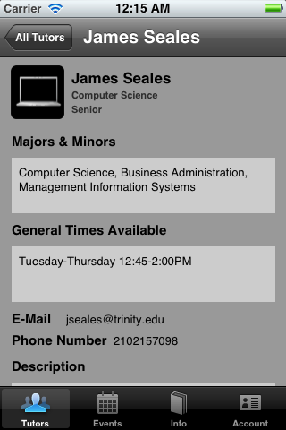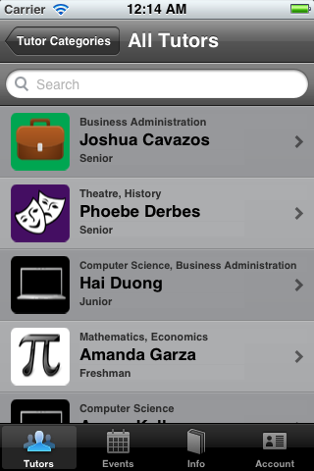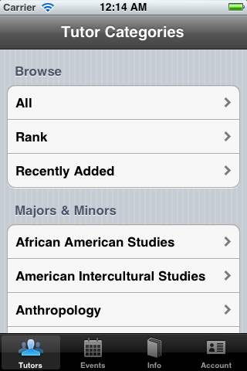

## Study Tab

This is the second tab/view of our application. Here the user is presented with a list of categories to choose from to help them filter the type of study events that they see. One they select a category there are presented with a searchable list of study events with quick look at the class name, class number, and event organizer name. The user simply selects an individual tutor to view more detailed information such as event description, date and time, location, contact information for the organizer, and RSVP information.

## 

## 

## Academic Information Tab

This is the third tab/view of our application. Here the user is presented two sections: Academic Calendar and Honor Code.. The user simply selects the semester they want to see the academic calendar for that term. In the Honor Code section, the user selects the one of the three information categories that they want to view.

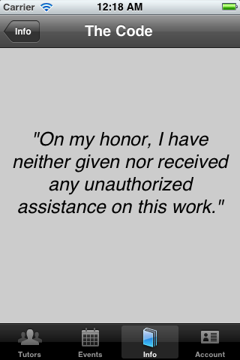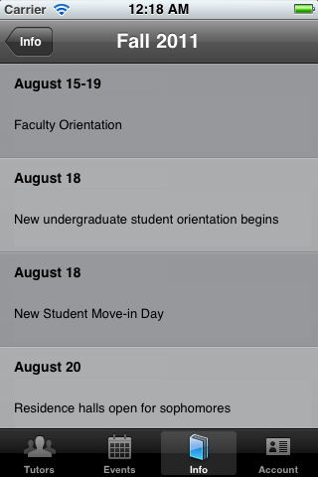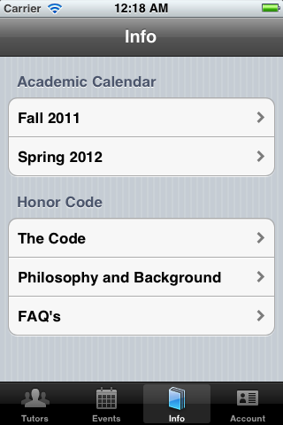

## Account Tab

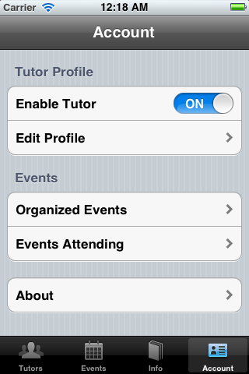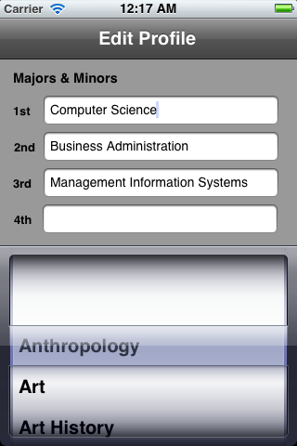This is the fourth and final tab/view of our application. Here the user is presented three sections: Tutor Profile, Events, and Settings. Enable Tutor is a toggle switch that will add the users tutor profile as active when enabled, and will disable their profile from viewing when disabled. Here the edit profile section allows the user to change their tutor information such as contact info, general times available and more. In the events section, the user is able to view the events they are the organizer of as well as the events they are attending. This allows the user a quick view instead of having to search for these events in the study events tab. The about section contains information regarding our application such as the members of the team as well as a link to compose an email if the user has any comments or questions regarding the application.

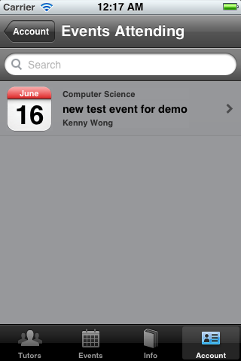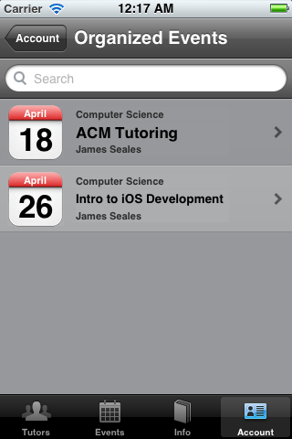

## 

# Original Requirements That Did Not Make It Into Final Version of the Application

## Event Reminders

We were unable to implement reminders for events that the user RSVP’d too. We had to focus on finishing the main functionality/stability of our application before attempting to code this feature, which we deemed “an extra, if time permits”

## Account Notifications

We decided that account notifications were beyond the scope of this project. For notifications to work correctly you need to have a functioning notification server that is up to par with certain Apple requirements.

# Incomplete Requirements/Features

## All implemented requirements and features are complete

# Known Bugs/Problems

## Android

Checkbox to enable/disable a user’s tutor profile in the account tab is currently not working correctly. Can be easily fixed with more effort into the functionality/proper way to change the value of this checkbox programmatically. Simply ran out of time.

## iOS

Edit tutor profile information in the account tab sometimes crashes. The problem are the “UIPicker’s” that display the list of majors and minors. Can be easily fixed with more effort into the functionality/proper coding of each of these “UIPicker’s” Simply ran out of time.